Azure Service Bus

What is Azure Service Bus and how does it compare to other messaging services available in the market?
Azure Service Bus is a fully managed, cloud-based messaging service that facilitates communication between applications and services through message queues, topics, and subscriptions. It supports asynchronous operations, decoupling of sender and receiver, and reliable message delivery.
Compared to other messaging services like RabbitMQ, Kafka, and Amazon SQS:
- Integration: Azure Service Bus integrates seamlessly with other Azure services, while others require additional setup for integration.
2. Protocol Support: Service Bus supports AMQP, HTTP/REST, and .NET APIs, whereas others may have limited protocol support.
3. Scalability: Service Bus offers auto-scaling capabilities, while some alternatives need manual scaling.
4. Message Retention: Service Bus retains messages up to 14 days, longer than most competitors.
5. Security: Service Bus provides built-in security features such as Shared Access Signatures and Managed Identities, ensuring secure communication.
6. Geo-Replication: Service Bus Premium tier offers geo-replication for disaster recovery, not available in all competing services.

What are the main components of Azure Service Bus?
The main components of Azure Service Bus are the message queues, topics, and subscriptions. Message queues are used to store messages that need to be processed by a service. Topics are used to group together related messages, and subscriptions are used to specify which messages a particular service should receive.

Explain the key differences between Queues, Topics, and Event Hubs in Azure Service Bus.
1. Queues: Simple one-to-one communication between sender and receiver. Supports first-in-first-out (FIFO) message delivery, dead-lettering, and duplicate detection. Ideal for point-to-point scenarios.
2. Topics: One-to-many communication using publish-subscribe pattern. Senders publish messages to a topic, while multiple subscribers receive filtered copies. Suitable for broadcasting or multicasting scenarios.
3. Event Hubs: High-throughput, low-latency ingestion service for real-time data streaming. Handles millions of events per second from various sources, enabling big data analytics and event-driven architectures.

Discuss the various message lock management strategies available in Azure Service Bus, and their respective use cases.
Azure Service Bus offers three message lock management strategies: Peek-Lock, Receive and Delete, and Deferral.
1. Peek-Lock: This strategy allows a receiver to peek at the message without removing it from the queue. The message remains locked for a specified duration, preventing other receivers from processing it. If the receiver successfully processes the message, it can be explicitly completed; otherwise, it becomes available again after the lock expires. Use cases include ensuring at-least-once delivery and handling scenarios where messages require complex processing or validation.
2. Receive and Delete: In this mode, messages are removed from the queue as soon as they’re received. It’s suitable for scenarios where message loss is acceptable, such as telemetry data collection or non-critical notifications.
3. Deferral: When a receiver cannot process a message immediately but wants to retain it for later processing, it can defer the message by storing its sequence number. Deferred messages remain in the queue until requested using their sequence numbers. This strategy is useful when dealing with messages that have dependencies on external resources or require specific processing order.

Can you describe a real-world scenario where you would use Azure Service Bus to integrate multiple systems or services?
In a multinational e-commerce company, Azure Service Bus can be used to integrate multiple systems and services for seamless order processing.
When a customer places an order,
The front-end system sends a message to the Service Bus queue.
Inventory management, shipping, and payment processing systems subscribe to this queue.
As messages arrive,
each system processes them independently and asynchronously.
The inventory system checks stock levels and updates product availability.
The shipping system calculates delivery times and assigns carriers.
The payment system handles transactions and generates invoices.
This decoupled architecture allows for scalability, fault tolerance, and easier maintenance. If one system fails or requires updates, others remain unaffected. Additionally, new systems can be added without disrupting existing workflows.

How can you use Azure Service Bus to enable message processing in a serverless architecture?
In a serverless architecture, Azure Service Bus can be used to enable message processing by leveraging its messaging capabilities and integrating with Azure Functions. This combination allows for efficient communication between distributed components without the need for dedicated servers.
First, create an Azure Service Bus namespace and define queues or topics/subscriptions as required. Queues provide point-to-point communication, while topics support publish-subscribe patterns. Configure access policies and connection strings for secure connectivity.
Next, develop Azure Functions that will process messages from the Service Bus. These functions can be triggered by incoming messages, allowing them to execute code in response to specific events. Use input bindings to read data from the Service Bus and output bindings to send processed messages back or to other destinations.
Configure the function’s trigger settings to listen to the desired queue or topic/subscription. Ensure proper scaling settings are applied to handle varying workloads efficiently.
Finally, deploy the Azure Functions and monitor their execution using Application Insights or other monitoring tools. Adjust configurations as needed to optimize performance and cost.

The most common message settlement operations are Complete, Abandon, Defer, and Dead-letter.

Complete
- Purpose: Marks the message as successfully processed and removes it from the queue or subscription permanently.
- Usage Scenarios: Use when your processing logic successfully handles the message without errors.
- Behavior: Once a message is completed, it is gone from the queue; it cannot be retrieved again.

. Abandon
- Purpose: Releases the message back to the queue or subscription without deleting it, making it available for reprocessing immediately or after a lock duration is renewed.
- Usage Scenarios: Use when you encounter a temporary issue and want the mestage to be retried later.
- Behavior: Increments the delivery count each time abandonment happens. If delivery count exceeds max delivery attempts, the message is moved to the dead-letter queue.

Defer
- Purpose: Postpones a message for future processing while keeping it in the queue. The message is hidden from normal Receive calls but can be retrieved later using its sequence number.
- Usage Scenarios: Use when the message cannot be processed at the moment but may be eligible later, e.g., dependency on external processes or conditions.
- Behavior: Deferred messages are not immediately redelivered; they must be explicitly requested using ReceiveDeferredMessageAsync(sequenceNumber).

1. Complete
- Definition: The Complete operation is used to indicate that a message has been successfully processed. Once a message is completed, it is removed from the queue or subscription and cannot be retrieved again.
- Use Case: Use this when your application has successfully handled the message and you want to ensure it is no longer available for processing by other consumers.

2. Abandon
- Definition: The Abandon operation is used when a message cannot be processed at the moment, but you want it to become available for processing again immediately. This operation releases the lock on the message, making it visible in the queue again.
- Use Case: This is useful when the processing fails due to temporary issues (e.g., a downstream service is unavailable). However, it is important to note that simply abandoning a message will not provide control over when it becomes available again, as it will reappear immediately in the queue.

3. Defer
- Definition: The Defer operation allows you to set a message aside for later processing. When a message is deferred, it remains in the queue but cannot be retrieved using standard receive operations. Instead, it must be accessed using its sequence number.
- Use Case: This is particularly useful in scenarios where the processing of a message depends on the completion of other messages. For example, if a payment notification arrives before the corresponding order is processed, you can defer the payment notification until the order is available.

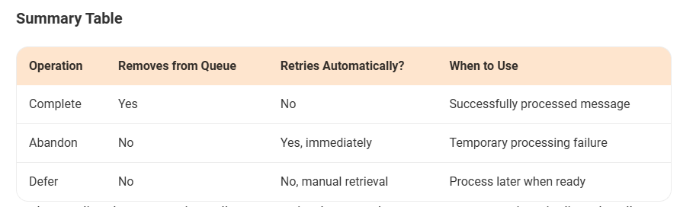

What is a Dead-Letter Queue (DLQ)?
A Dead-Letter Queue (DLQ) is a secondary sub queue associated with Azure Service Bus queues and topic subscriptions. It is automatically created and cannot be deleted or managed independently of the main queue or subscription. The primary purpose of the DLQ is to hold messages that cannot be delivered to any receiver or messages that could not be processed due to various reasons, such as exceeding the maximum delivery count or failing to match filter criteria

When Do Messages Go to the DLQ?
Messages may be sent to the DLQ under several conditions, including:
- The message exceeds the maximum delivery count.
- The message does not match the filter criteria for subscriptions.
- The message's time-to-live (TTL) has expired.
- The message's header size exceeds the allowed quota
- If a consumer application cannot process the message due to missing data or incorrect format.

Why is a Dead Letter Queue Important?
- Ensures No Data is Lost: Messages that cannot be processed remain available for later review and action.
- Facilitates Debugging and Analysis: By inspecting DLQ messages, developers can identify common errors and trends in message failures.
- Allows Reprocessing and Recovery: Messages can be corrected and reprocessed, preventing permanent data loss or system failures.
- Improves System Reliability: Applications that handle DLQ messages proactively ensure consistent and dependable operations.

1)Queue:
- Purpose: Facilitates point-to-point communication.
- Behavior: A single message is delivered to and processed by only one consumer.

2)Topic:
- Purpose: Enables publish/subscribe messaging for one-to-many communication.
- Behavior: It acts as an intermediary, where publishers send messages to the topic without knowing about the subscribers. The topic ensures a message is distributed to all relevant subscriptions.

3)Subscription:
- Purpose: Represents a specific subscriber or receiver of messages from a topic.
- Behavior: Each subscription receives a copy of every message sent to the topic. You can apply filters to a subscription to specify which messages it should receive, making it a "virtual queue" tailored for that subscriber.

Types of Filters in Azure Service Bus

SQL Filter
  - Uses a SQL-like syntax to evaluate message properties.
They support various operations like equality (=), inequality (!=), comparisons (>, <, >=, <=), LIKE for pattern matching, EXISTS to check for property existence, and IS NULL to check for null values.

System properties are referenced using sys.<property-name>, e.g., sys.Label LIKE '%order%'. User-defined properties are referenced directly by their name.

  - Example:
SQL
sys.Label = 'HighPriority' AND CustomProperty = 'Value1'
Show more lines
  - You can filter on:
    - System properties (e.g., sys.Label, sys.MessageId)
    - Custom user-defined properties

Correlation Filter
  - Matches messages based on a specific set of properties.
  - Simpler and faster than SQL filters for exact matches.
  - Example:
C#
new CorrelationFilter
{
Label = "HighPriority",
CorrelationId = "12345"
}
Show more lines

True Filter
  - Matches all messages (default filter).
  - Equivalent to 1=1 in SQL.

False Filter
  - Matches no messages.

🛠️ Example: Adding a SQL Filter in C#
C#
var subscriptionClient = new SubscriptionClient(connectionString, topicName, subscriptionName);

var ruleDescription = new RuleDescription
{
Filter = new SqlFilter("Priority = 'High'"),
Name = "HighPriorityFilter"
};

await subscriptionClient.AddRuleAsync(ruleDescription);
Show more lines

🛠️ Example: Adding a Correlation Filter
C#
var correlationFilter = new CorrelationFilter
{
Label = "Invoice",
CorrelationId = "INV-1001"
};

await subscriptionClient.AddRuleAsync(new RuleDescription("InvoiceFilter", correlationFilter));

Show more lines

🧠 Best Practices

Best Practices
- Use Correlation Filters for performance when matching on exact values.
- Use SQL Filters for complex logic.
- Always remove the default rule ($Default) if you're adding custom filters:
C#
await subscriptionClient.RemoveRuleAsync(RuleDescription.DefaultRuleName);
Show more lines

Scenario where used Service Bus:

Using Azure Service Bus in a .NET Core API for email notifications involves sending messages to a Service Bus queue and then having a separate consumer (e.g., an Azure Function) process these messages to send emails.
1. Azure Setup:
- Create a Service Bus Namespace: In the Azure portal, create a Service Bus namespace.
- Create a Queue: Within the namespace, create a queue (e.g., "emailnotifications").
- Get Connection String: Obtain the connection string for your Service Bus namespace from the "Shared access policies" section.

2. .NET Core API (Producer):
- Install NuGet Package: Install Azure.Messaging.ServiceBus in your .NET Core API project.
- Configure: Add your Service Bus connection string and queue name to your appsettings.json.
- Send Messages: In your API, when an email notification is needed, create a ServiceBusClient and ServiceBusSender to send messages to the queue.
Code
// appsettings.json
{
"AzureServiceBus": {
"ConnectionString": "Endpoint=sb://yournamespace.servicebus.windows.net/...",
"QueueName": "emailnotifications"
}
}

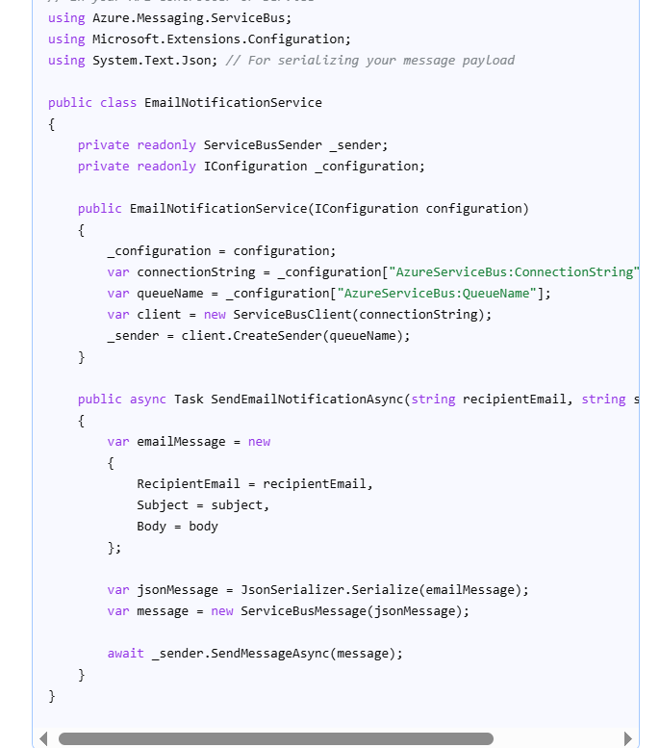

3. Azure Function (Consumer):
- Create an Azure Function:
Create a new Azure Function project with a Service Bus Queue Trigger.
- Install NuGet Packages:
Install Azure.Messaging.ServiceBus and any necessary email sending libraries (e.g., SendGrid, Azure.Communication.Email).
- Configure:
Add the Service Bus connection string (and email service credentials) to the Function App's configuration.
- Process Messages:
The Function will automatically trigger when a message arrives in the queue. Deserialize the message and use an email sending service to send the email.

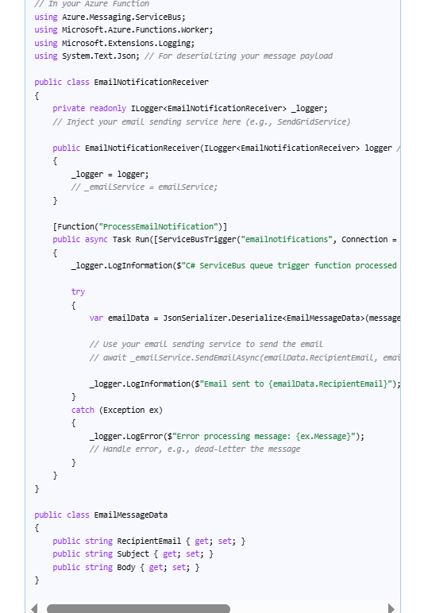

Diff between Event Hubs and Service Bus:
Event Hubs are for high-throughput, real-time event streaming like telemetry and big data pipelines, while Service Bus is for reliable, ordered message messaging like order processing and financial transactions.
Event Hubs ingest millions of events per second but provide fewer guarantees, whereas Service Bus offers features like guaranteed delivery, transactions, and strict ordering for more critical, lower-volume workloads

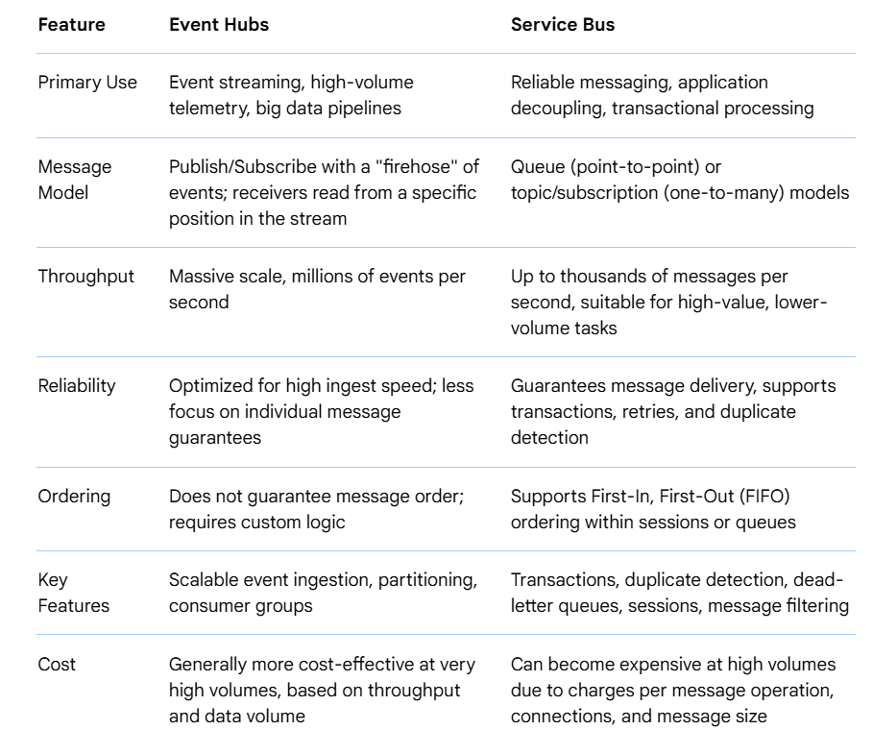

Azure Function | Azure Web jobs
Useful for lighter and short-lived tasks, making full use  of serverless scenarios. | Suitable for longer running and resource  intensive processes  that require a dedicated environment.
Offers a wider range of event triggers,  including HTTP, Timers, Queues, Service Bus, Cosmos database | Trigger types supported include continuous, on-demand,  and scheduled.
Designed for serverless deployment. | Deployed as part of an Azure App Service.
Follows a pay per use or consumption-based pricing model. | Costs depend on hosting plan of the associated App Service,  hence may vary.
it is generally cheaper. | As this is used for longer running tasks,  may lead to higher costs.

